Problem No: 01
Problem Statement: Simplifying the Boolean expression F(A, B, C) = A′BC + AB′C + ABC′ + ABC using Boolean algebra and a Karnaugh map, and then checking the original and simplified circuits through logic simulation.
Objective: To reduce a three-variable Boolean function using Boolean algebra and a Karnaugh map, and verify through Logisim that the original and simplified circuits produce identical outputs.

Algebraic Simplification:
F (A, B, C) = A′BC + AB′C + ABC′ + ABC
= A′BC + ABC + AB′C + ABC + ABC′ + ABC
= BC (A′ + A) + AC (B′ + B) + AB (C′ + C)
= BC + AC + AB
= AB + AC + BC

Truth Table:

A | B | C | F = AB + AC + BC
0 | 0 | 0 | 0
0 | 0 | 1 | 0
0 | 1 | 0 | 0
0 | 1 | 1 | 1
1 | 0 | 0 | 0
1 | 0 | 1 | 1
1 | 1 | 0 | 1
1 | 1 | 1 | 1

Karnaugh Map:

BC  A | 00 | 01 | 11 | 10
0 | 0 | 0 | 1 | 0
1 | 0 | 1 | 1 | 1
This is a 3-variable K-map for A, B, and C. The 1s show where the output is 1.By grouping the 1s, the simplified expression is:
F = AB + AC + BC

Circuit Diagram:

Original Circuit:
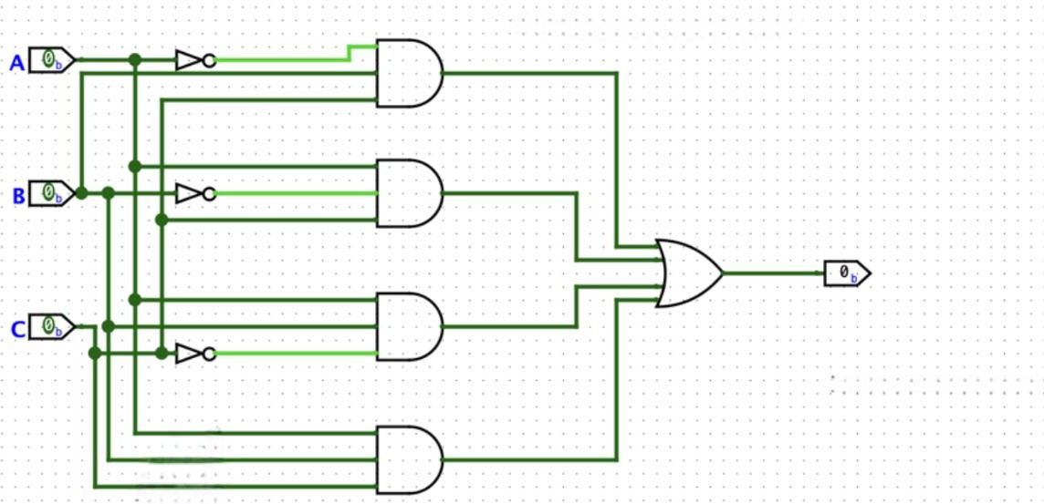

Simplified Circuit:
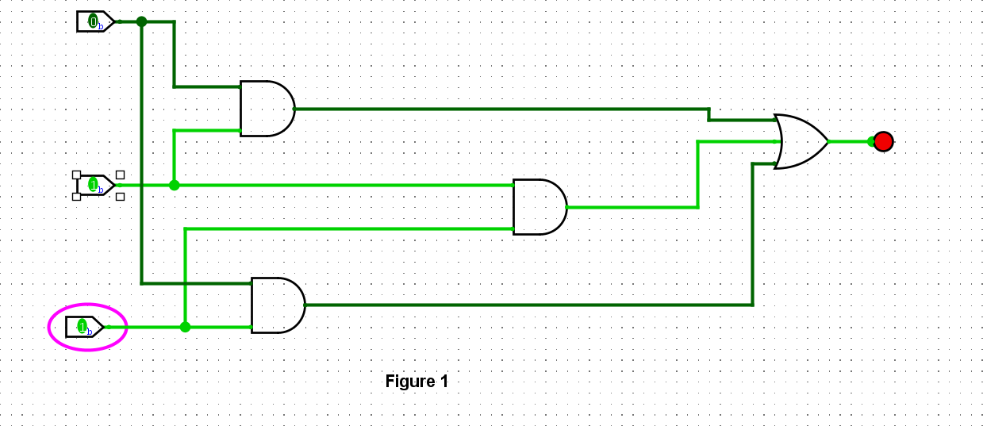
.

Discussion:
In this experiment, the given Boolean function was reduced using two different approaches: Boolean algebra and the Karnaugh map technique. Both methods resulted in the same simplified form, (F = AB + AC + BC). The original circuit and the simplified version were then designed and simulated in Logisim. After testing every possible combination of inputs, both circuits were found to generate identical outputs. This confirms that the simplified circuit is logically equivalent to the original one while requiring fewer logic gates.

Problem No: 02
Problem Statement:To reduce the Boolean function (F(A,B,C)=A(A+B)(A+B+C)) using Boolean algebra and the Karnaugh map technique, and subsequently verify the original and simplified circuits through logic simulation.
.
Objective: To simplify a three-variable Boolean expression using Boolean algebra and a Karnaugh map, and verify that the original and simplified circuits give the same output using Logisim.

Algebraic Simplification:

F(A,B,C)= A(A+B)(A+B+C)
=(A+AB)(A+B+C)
=A(A+B+C)+AB(A+B+C)
=A+AB+AC+AB+AB+ABC
=A+AB+AC+ABC
=A(1+B+C+BC)
=A

Truth Table:

A | B | C | F = A
0 | 0 | 0 | 0
0 | 0 | 1 | 0
0 | 1 | 0 | 0
0 | 1 | 1 | 0
1 | 0 | 0 | 1
1 | 0 | 1 | 1
1 | 1 | 0 | 1
1 | 1 | 1 | 1

Karnaugh Map:

BC  A | 00 | 01 | 11 | 10
0 | 0 | 0 | 0 | 0
1 | 1 | 1 | 1 | 1

This is a 3-variable K-map for A ,B and C . The entire row where A = 1 contains 1s, while the row where A = 0 contains 0s. By grouping the four 1s together, B and C are eliminated. Therefore, the simplified expression is:
F = A

Circuit Diagram:

Original Circuit:
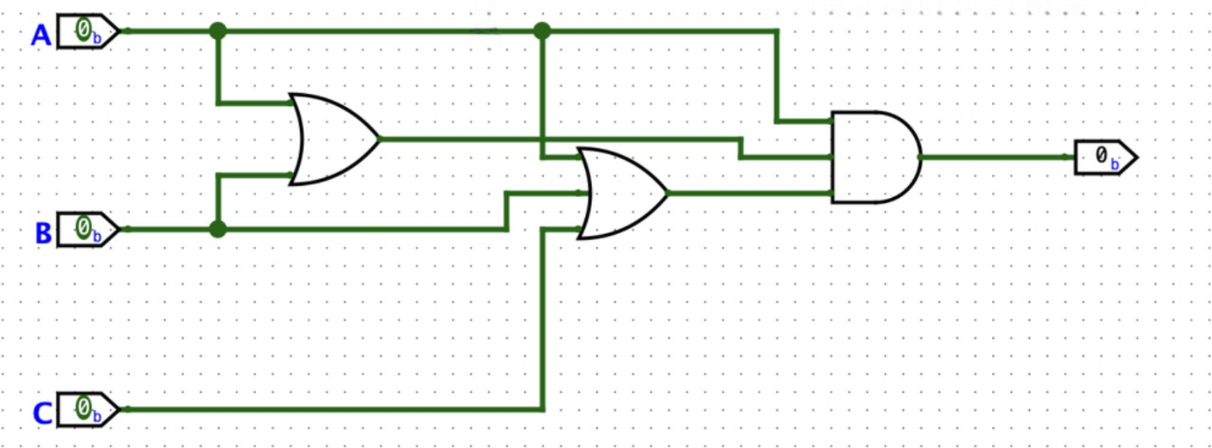

Simplified Circuit:
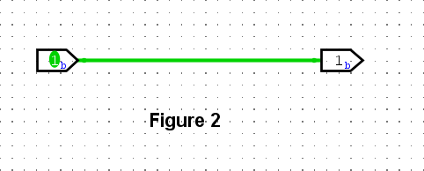
.

Discussion:
In this experiment, the given Boolean function was simplified using both Boolean algebra and the Karnaugh map approach. In both cases, the resulting expression was (F=A). The original and reduced circuits were then constructed and simulated in Logisim. Testing all possible input combinations confirmed that both circuits produced identical outputs. Hence, the result verifies that the values of (B) and (C) have no influence on the output.

Problem No: 03
Problem Statement: Simplifying the Boolean expression F(A, B, C) = (A + (BC)′)′(AB + ABC) using Boolean algebra and a Karnaugh map, and then checking the original and simplified circuits using logic simulation.
Objective: To simplify a Boolean expression using De Morgan’s theorem and Boolean algebra, verify the result using a Karnaugh map, and check the original and simplified circuits using Logisim.

Algebraic Simplification:
F(A, B, C) = (A + (BC)′)′(AB + ABC)
= A′ · BC · (AB + ABC) (De Morgan’s theorem)
= A′BC · AB(1 + C)
= A′BC · AB
= (AA′)BCB
= 0
Therefore, the simplified expression is: F = 0

Truth Table:

A | B | C | F = 0
0 | 0 | 0 | 0
0 | 0 | 1 | 0
0 | 1 | 0 | 0
0 | 1 | 1 | 0
1 | 0 | 0 | 0
1 | 0 | 1 | 0
1 | 1 | 0 | 0
1 | 1 | 1 | 0

Karnaugh Map:

BC  A | 00 | 01 | 11 | 10
0 | 0 | 0 | 0 | 0
1 | 0 | 0 | 0 | 0
This is a 3-variable K-map for A, B, and C. All the cells contain 0, so there are no 1s to group. Therefore, the simplified expression is:
F = 0

Circuit Diagram:

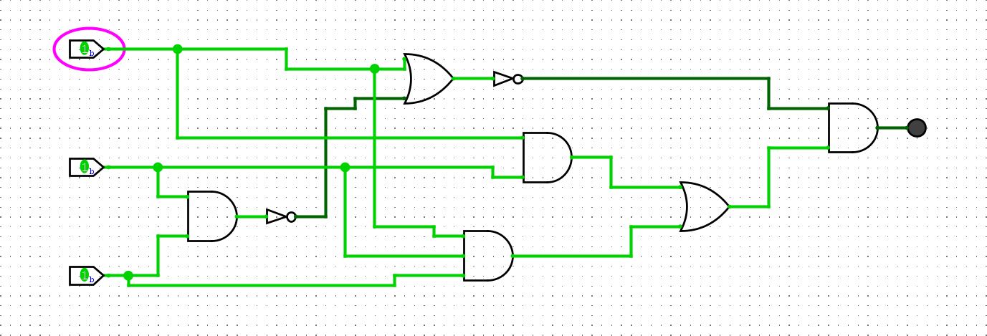
Original Circuit:
Simplified Circuit:
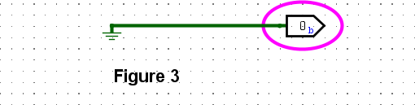
.

Discussion:
In this experiment, the given Boolean expression was reduced using De Morgan’s theorem along with Boolean algebra. The final simplified result was (F=0), since the product (AA') always evaluates to zero. The Karnaugh map also consisted entirely of 0s, supporting the same conclusion. Both the original and simplified circuits were designed and simulated in Logisim, where the output remained 0 for every possible combination of inputs. Thus, the simulation confirms that the two circuits are functionally equivalent.

Problem No: 04
Problem Statement: Simplifying the Boolean expression F(A, B) = (B′(A + B) + (A + B)(A + B′))B′ using Boolean algebra and a Karnaugh map, and then checking the original and simplified circuits using logic simulation.
Objective: To simplify a two-variable Boolean expression using Boolean algebra and a Karnaugh map, and verify that the original and simplified circuits give the same output using Logisim.

Algebraic Simplification:
F(A, B) = (B′(A + B) + (A + B)(A + B′))B′
= (AB′ + BB′ + AA + AB′ + AB′ + BB′)B′
= (A + AB′ + AB′ + AB′)B′
= A(1 + B′ + B′ + B′)B′
= AB′
Therefore, the simplified expression is: F = AB′

Truth Table:

A | B | F = AB′
0 | 0 | 0
0 | 1 | 0
1 | 0 | 1
1 | 1 | 0

Karnaugh Map:

B  A | 0 | 1
0 | 0 | 0
1 | 1 | 0
This is a 2-variable K-map for A and B. Only one cell contains 1, which occurs when A = 1 and B = 0.Therefore, the simplified expression is:
F = AB′

Circuit Diagram:

Original Circuit:
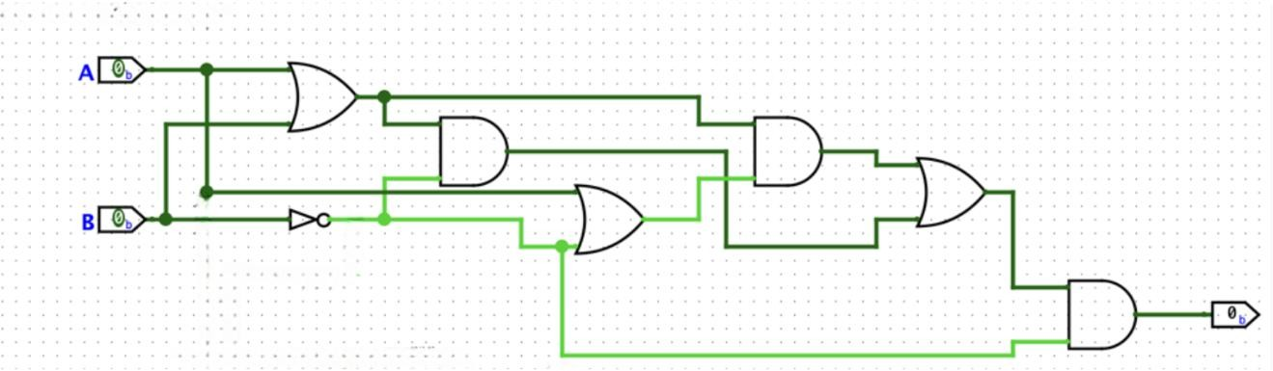

Simplified Circuit:
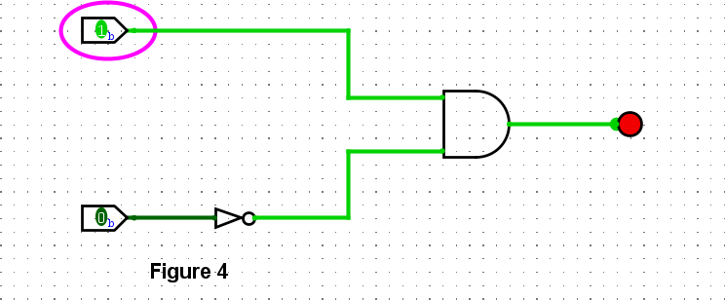
.

Discussion:
In this experiment, the given Boolean expression was simplified using Boolean algebra and the Karnaugh map method. Both methods produced the same simplified expression, F = AB′. The original and simplified circuits were then implemented and tested in Logisim. The simulation showed that the output is 1 only when A = 1 and B = 0. For all other input combinations, the output is 0. Therefore, both circuits are functionally equivalent.

Conclusion:
Four Boolean expressions were simplified successfully using Boolean algebra and Karnaugh maps, producing (F=AB+AC+BC), (F=A), (F=0), and (F=AB').
The K-maps supported the algebraic results, while Logisim simulations confirmed that the original and simplified circuits generated identical outputs.
Thus, Boolean simplification reduces gate usage and circuit complexity while maintaining the same functionality.

